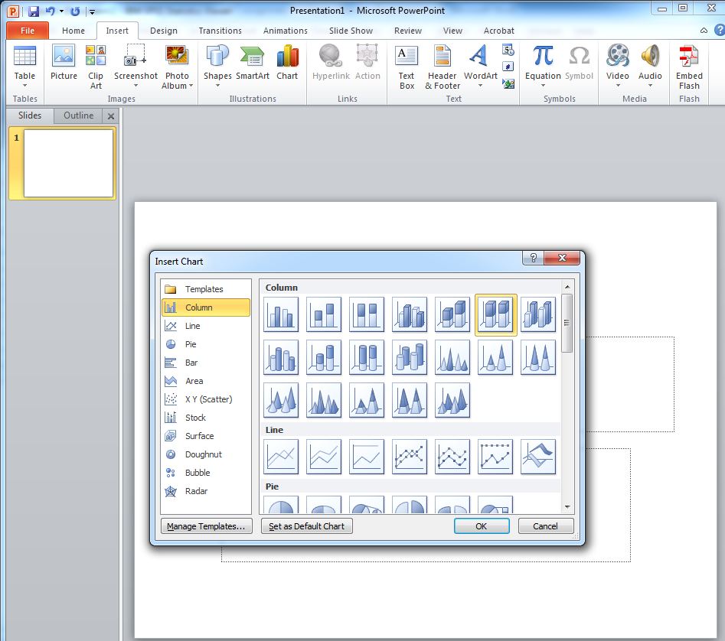
PowerPoint Instructions

-under the “insert” tab, click on chart. Select “100% stacked column in 3D”

-An excel spreadsheet will pop up. Fill in the data from your crosstab. You’ll need to expand the range to fit all your categories (no need to include the totals row)

-Across the top where it says ‘series 1’ will be your hours worked categories

-down the side will be your age categories
*be careful when you fill in the data, it won’t match your crosstab exactly but will be flipped

-click on the title bar to add a title. Ex: hours worked by sex.
-insert a text box to label the bottom. Ex: sex of respondent
-insert a text box to label above the key/legend. Ex: hours worked

